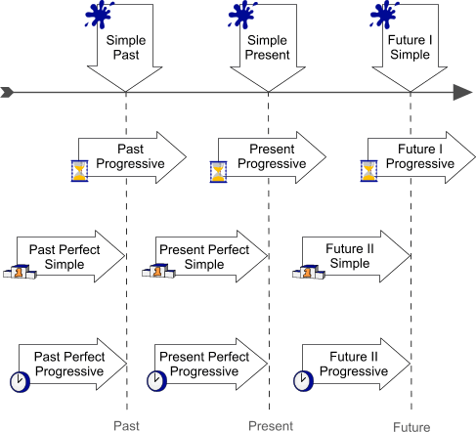
Explanation of signs
  moment in time | - action that takes place once, never or several times  - actions that happen one after another  - actions that suddenly take place
period of time | - action that started before a certain moment and lasts beyond that moment  - actions taking place at the same time
Result | - action taking place before a certain moment in time  - puts emphasis on the result
  Course / Duration | - action taking place before a certain moment in time  - puts emphasis on the course or duration of the action

