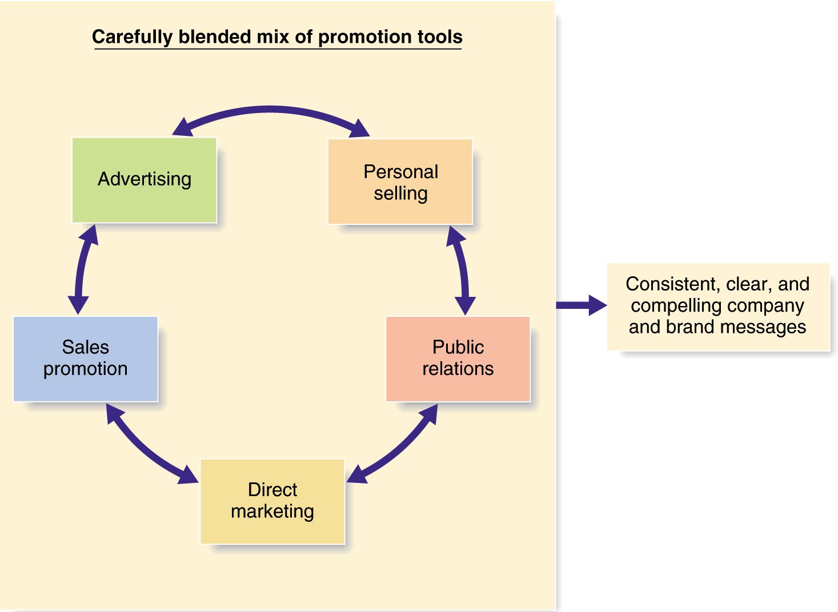
Definition: Advertising is the paid form of non-personal presentation and promotion of ideas, goods and services by an identified sponsor through the various media. It is used to achieve specific marketing objectives as it is part of the marketing mix.

I. Reasons why companies advertise: •to announce a new product, •to announce a product modification, •to announce a price change, •to make a special offer, •to attract attention, •to invite a flow of enquires, •to sell directly, •to obtain inventory, •to educate customers, •to maintain continuous sales, •to challenge competition, •to remind the customers of the Brand Name, •to recruit staff, •to influence political decisions, •to penetrate international markets, •to move between commercial and business markets

II. Functions of advertising: To identify products and differentiate them from others, ▪ To communicate information about the product or the company, ▪ To induce consumers to try new products and to suggest reuse, ▪ To stimulate the demand and the distribution, ▪ To build brand awareness, preference and loyalty, ▪ To lower the cost of sales, ▪ To reinforce the customer’s satisfaction, ▪ To remind them of the product’s positive distinctive features

III. Developing an advertising programme:
1, To set communication and sales objectives such as to fortify the company’s image or to inform, convince, remind consumers of the company’s products, to reinforce loyalty, increase sales or to strengthen the market position or to realise market growth.
2, To make the budget decision by different methods such as Affordable or All-You-Can-Afford, or Percentage of sales, Competitive parity, or Objective and task method,
3, To appoint an agency or work with the company’s own marketing department. Agencies are the core of the advertising industry. A large advertising agency may employ hundreds of people, including advertising and marketing specialists, designers, writers known as copywriters, artists, economists, psychologists, researchers, media analysts, product testers, librarians, accountants and bookkeepers, and mathematicians and has the necessary equipment at its disposal.
4, To formulate creative message and message execution strategies which means to involve all the activities that help transform the advertising objectives into a sensible campaign theme and to choose the proper tone, the proper format elements, attention catching words, slogans, illustrations, copy and graphic appeals.
5, Formulating the media strategy Communication vehicles or media are channels in which the message is forwarded to the audience which are chosen in terms of target audience, reach and frequency. Major (mass) media types are press, radio, Tv. Specific (niche) media types are cable Tv, cinema, direct mail, brochures and booklets, symbols and logos, leaflets, Yellow Pages or directories, outdoor ads, point-of-purchase. The internet is not a conventional advertising media because it serves as a transaction and distribution channel at the same time.
6. Implementation of the advertising plan and finally
7. Evaluation of the advertising efficiency. Very simply the whole process can be summarised in 5Ms: Mission = the aim, Message = the target audience, Money = the budget, Media = communication tools and Measurement = evaluation of the effectiveness

IV. Regulations of advertising
Advertising is heavily regulated in advanced countries but the regulations vary from country to country. Advertising is subject to both government regulation and industry self-regulation to prevent deceptive advertising. Trade Commission enforces a variety of consumer protection laws to eliminate ads that deceive the consumers. The key to the TC's regulation of advertising is its power to require that advertisers substantiate the accuracy of their claims. So if advertisers say that 'tests prove' or 'physicians recommend,' they must be able to show test results or affidavits from doctors. Products that can affect health receive special regulatory attention. Advertising directed to children has received considerable scrutiny. This law sets limits on the amount of advertising that could be included in children's television programming and barred hosts of children's shows from selling products.
The advertising industry has resorted to self-regulation in a serious effort to stop abuses before they occur. These self-imposed codes of ethics and procedures aim principally to curtail not only bad taste but also misrepresentation and deception in copy and illustrations, as well as derogatory and unfair representations of products of competitors. Individual media and media groups often establish their own codes of ethics. Some newspapers and magazines refuse to publish advertising for tobacco and alcoholic beverages and they also investigate the reliability of advertisers before accepting their copy. The Institute of Outdoor Advertising encourages its members to improve the design of their advertising posters and signs to make sure they do not mar the landscape or offend the public with their billboards. Advertising regulations are often designed to protect culture and morals. France prohibits the use of foreign expressions where there are equivalent French terms. Advertising regulations in Malaysia bar the depiction of nudity, disco dancing and seductive clothing. Varying regulations present numerous challenges to multinational corporations that advertise their products in many different countries.

