Economic agents

The financial system is made up of financial institutions that essentially channel savings into investment in financial markets by buying and selling financial products.
These institutions are intermediaries between economic agents that may be savers at one time and investors at another.
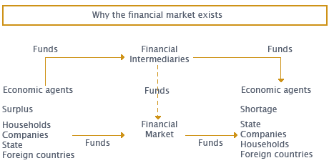

Economic agents are any individuals, institutions or groups of institutions that play a part in any economic circuit through their rational actions and decisions. Although they have different roles in the economic, production, investment or consumption circuit, they establish essential economic relationships with each other:
State - Makes consumption, investment and economic policy decisions;
Households - Make decisions on consumption of goods and services and on savings, depending on their income;
Companies - Make investment, production and employment decisions.
These three agents and financial institutions are part of a closed economy. However, it is increasingly necessary to consider a fourth agent - outside regions / foreign countries with which the other economic agents do considerable business in an open economy.

